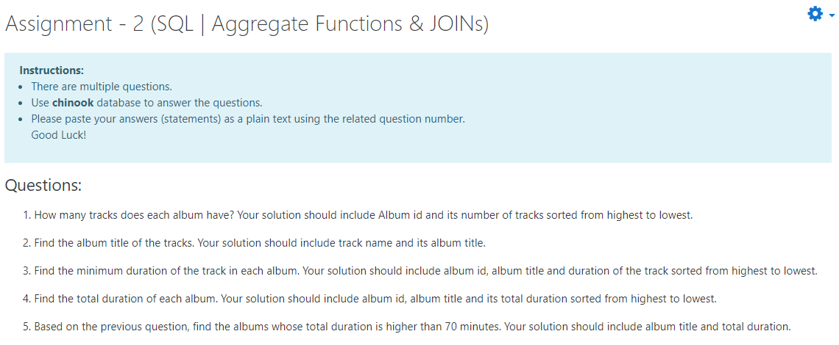

SELECT albums.Title as album_adı,count(TrackId) as Track_sayısı

from tracks

inner JOIN albums

on tracks.AlbumId = albums.AlbumId

GROUP by albums.AlbumId

order by count(trackid) DESC

​

SELECT tracks.Name as track_name, albums.Title as album_name

from tracks

inner JOIN albums

on albums.AlbumId = tracks.AlbumId

​

SELECT tracks.Name as track_name, albums.AlbumId,albums.Title as album_title, tracks.Milliseconds as duration

from tracks

join albums

on tracks.AlbumId = albums.AlbumId

order by Milliseconds DESC

​

SELECT --tracks.name as track_name,

albums.AlbumId, albums.Title as album_Title , sum(tracks.Milliseconds) as total_duration

from tracks

join albums

on tracks.AlbumId = albums.AlbumId

GROUP by albums.Title

ORDER by sum(tracks.Milliseconds) DESC

​

SELECT albums.Title, sum(tracks.Milliseconds) as total_duration

from tracks

join albums

on albums.AlbumId = tracks.AlbumId

GROUP by albums.Title

HAVING sum(Milliseconds) > 4200000